Model: UT-210T

(Product Name：RS-232 to TTL converter )

User manual


UTEK TECHNOLOGY (SHENZHEN) CO., LTD.
Add: Room 1001, Building 7, Skyworth Innovation Valley, No. 8, Tangtou No.1 Road, Shiyan Street, Shiyan Old Street, Bao 'an District, Shenzhen
Tel：+86-755-81202008
Fax：+86-755-27886083
Http：www.uotek.com

1. Overview

In order to facilitate data communication between external devices or intelligent instruments equipped with different standard serial interfaces, it is necessary to convert the standard serial interfaces. UT-210T interface converter can convert the RS-232C serial interface data transmission (TXD) and data reception (RXD) signals into TTL/COMS compatible level, and the converted TTL level is 0-3.3V, No external power supply is required. Driven by a unique "RS-232 charge pump", power can be obtained without initializing the RS-232 serial port. It has zero-delay automatic sending and receiving conversion inside, and the unique I/O circuit automatically controls the data flow direction. Without any handshaking signals (such as RTS, DTR, etc.), it ensures that programs written in RS-232 in full-duplex mode can run in TTL mode without modification, ensuring that it is suitable for existing operating software and interface hardware. Converter transmission rate 300-115.2Kbps.

2. Major Functions & Features
- Interface characteristics: The interface is compatible with RS-232C and TTL/COMS standards of EIA/TIA
- Electrical interface: RS-232 terminal DB9 female connector, TTL terminal DB9 pin connector.
- Working mode: asynchronous full duplex
- Transmission medium: twisted pair or shielded wire
- Transmission rate: 300BPS-115.2KBPS
- Dimensions: 63mm*33mm*17mm
- Operating environment: -25°C to 70°C, relative humidity 5% to 95%
- Transmission distance: 5m

3. Connector&signal
RS-232C pin allocation
DB9 Female(PIN) | RS-232C interface signal
1 | DCD
2 | SOUT (TXD)
3 | SIN (RXD)
4 | DTS
5 | GND
6 | DTR
7 | RTS
8 | CTS
9 | RI

TTL output signal pin allocation
DB9 Male(PIN) | output signal | TTL output (3.3V)
1 | RXD | RXD
2 | TXD | TXD
3 | None | None
4 | None | None
5 | GND | GND
6，7，8，9 | None | None

5. Electrical Interface
DB9 demale
DB9 male

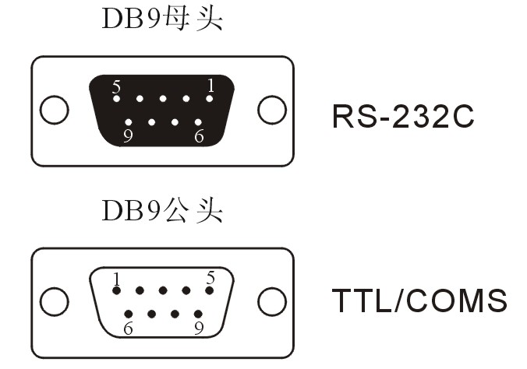

5. Appearance

