Model:UT-6616M-I

10/100M TCP/IP to 16 Ports RS-485/422 Serial Device Serve
with Opto-Electronic Isolation

Datasheet

UTEK TECHNOLOGY (SHENZHEN) CO., LTD.
Add: Floor 8-10, Building 7, Skyworth Innovation Valley, No. 8, Tangtou No.1 Road, Shiyan Street, Shiyan Old Street, Bao 'an District, Shenzhen
Tel：+86-755-81202008
Fax：+86-755-27886083
Http：www.uotek.com


- Overview
UT-6616M-I series serial device server, is a converter between asynchronous serial port RS-422/485 and Ethernet. It is a standalone intelligent device with CPU and embedded OS and full TCP/IP protocol stack. It completes transparent data transfer between RS-422/485 and Ethernet in both directions, allowing RS-422/485 serial devices to connect to the network immediately.

- Technical Parameters
Hardware
● UNIX Fixedtty mechanism
● With 16 serial ports, it can be connected to various serial devices such as terminals, Modems, barcode machines, cash registers, ISDN, terminal adapters, serial printers and PCs.
● With Reset button
● Ethernet port 10/100M transmission rate, auto negotiation
● Provides with full signal: TR+, TR-, RXD+, RXD-, GND.
● 32 bits embedded 100M CPU, 8M RAM
● LED indication for working status
Software
● Support ARP, IP, ICMP, UDP, TCP, PPP, HTTP, TELNET, DNS, DHCP, PAP, CHAP.
● Support Windows extended Serial Mode
● Support UNIX host login mode
● Support DNS
● Support ARP
● Terminal server parameters configuration
● Support for status monitoring
● Support MODEM connection

Product model |  | UT-6616M-I
serial port number |  | 16
CPU |  | 32bit 100MHZ
RAM |  | 8M
Serial port | Baud rate | 50-460800bps
Serial port | Check bit | Nove,Odd, Even, Mark, Space
Serial port | Data bit | 5,6,7,8
Serial port | Stop bit | 1, 1.5, 2
Serial port | Flow control | RTS/ CTS, XON/ XOFF
Serial port | Form | Binding post
Serial port | Serial port protection | 3KV lightning and surge protection | ±15KV Anti-static protection
Serial port | Isolation protection | Isolation voltage 2500V rms
Serial port | Signal | RS422:TXD+/RXD+/TXD-/RXD-/GND, RS485:Data+/Data-
Ethernet port | Rate | Auto-10/100M
Ethernet port | Form | RJ45
Ethernet port | Protection | 3KV lightning and surge protection
Software | Protocol | ARP, IP, ICMP, UDP, TCP, PPP, HTTP, TELENT, DNS, DHCP, PAP, CHAP
Software | Virtual COM | Window NT/2000/XP
Environment | Operating temperature | -10 ~60℃
Environment | Operating humidity | 5 ~ 95%
Environment | Storage temperature | -20 ~ 85℃
Environment | Storage humidity | 5 ~ 95%
Certification |  | FCC, CE
Power |  | AC 220V
Appearance | Material | Metal housing
Appearance | Dimension | 19 inches, IU height

- Pin definition
Front side of terminal
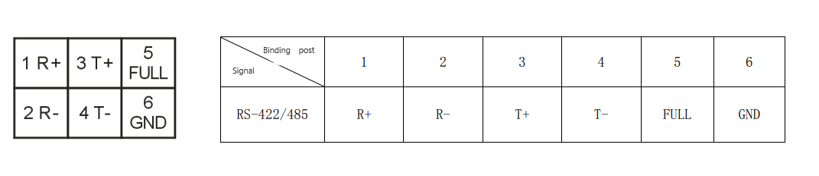

RS-422 full duplex connection
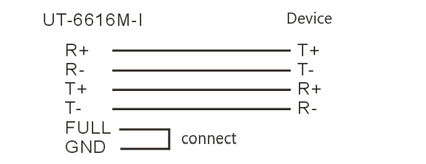

RS-485 half-duplex connection
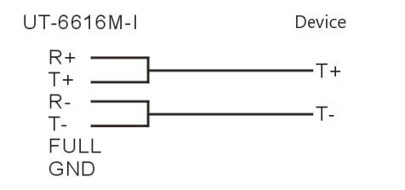

- Product View (Appearance)

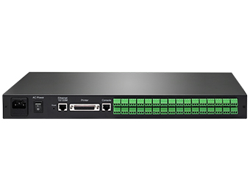
- Structure Dimensions

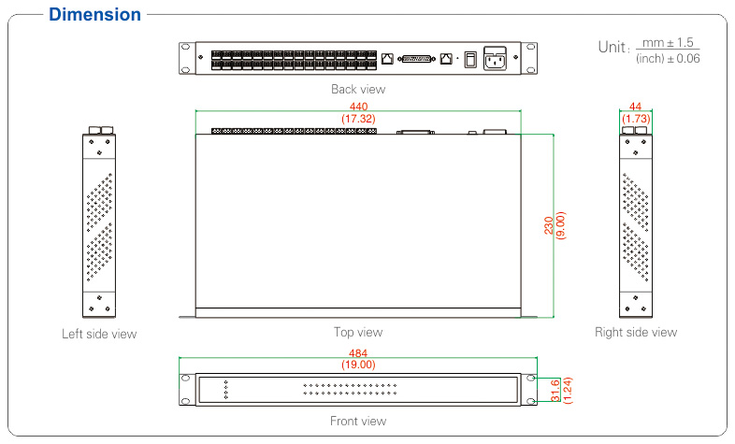

- Ordering Information
Model | Signal/ Interface |  | Port number |  | Interface protection level |  | Operating Environment |  |  | Power
Model | TCP/IP | RS-485/422 |  |  |  |  | Temperature |  | Humidity
Model | RJ45 | RJ45 | TCP/IP | RS-485/422 | TCP/IP | RS-485/422 | -10~60℃ | -40~85℃ | 5~95% | plug and play | External power
UT-6616M-I | √ | √ | 1 | 16 | 3KV lightning protection |  | √ |  | √ |  | 220VAC

